Q1 | Connect to a MySQL or PostgreSQL database using SQLAlchemy and pandas, then use pd.read_sql() to load the entire 'restaurants' table (imagine Zomato backend) into a DataFrame and display the first 5 rows.
Code | import pandas as pd  from sqlalchemy import create_engine  engine = create_engine("sqlite:///:memory:")  restaurants_demo = pd.DataFrame({  "id": range(1, 8),  "name": ["Spice Route", "Pizza Planet", "Curry Leaf", "Sushi Zen",  "Burger Barn", "Tandoori Nights", "Pasta Palace"],  "cuisine": ["Indian", "Italian", "Indian", "Japanese",  "American", "Indian", "Italian"],  "city": ["Ahmedabad", "Mumbai", "Delhi", "Bengaluru",  "Ahmedabad", "Pune", "Mumbai"],  "rating": [4.3, 4.1, 4.5, 4.7, 3.9, 4.4, 4.0],  })  restaurants_demo.to_sql("restaurants", engine, index=False, if_exists="replace")  restaurants_df = pd.read_sql("restaurants", con=engine)  print(restaurants_df.shape)  restaurants_df.head(5)
Output | 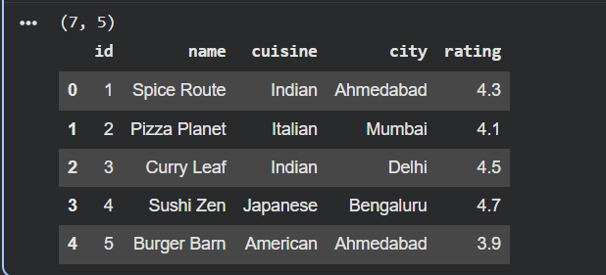

Q2 | Use pd.read_sql_query() to fetch only the 'name' and 'rating' columns from a 'movies' table (think BookMyShow-like data) where rating is above 8, and print the resulting DataFrame.<br><br><em><strong>Hint:</strong> Write a custom SQL SELECT query as the first argument to pd.read_sql_query().</em>
Code | movies_demo = pd.DataFrame({  "movie_id": range(1, 8),  "name": ["Interstellar", "The Room", "Inception", "Dangal",  "3 Idiots", "Sharknado", "Parasite"],  "genre": ["Sci-Fi", "Drama", "Sci-Fi", "Drama",  "Comedy", "Comedy", "Thriller"],  "rating": [8.6, 3.7, 8.8, 8.4, 8.4, 2.6, 8.5],  })  movies_demo.to_sql("movies", engine, index=False, if_exists="replace")  query = """  SELECT name, rating  FROM movies  WHERE rating > 8  """  top_movies_df = pd.read_sql_query(query, con=engine)  print(top_movies_df)
Output | 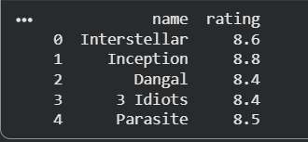

Q3 | Read a JSON dataset from the URL https://jsonplaceholder.typicode.com/users using pandas, convert it into a DataFrame, and print the usernames column.<br><br><em><strong>Hint:</strong> Use pd.read_json() directly with the URL.</em>
Code | users_df = pd.read_json("https://jsonplaceholder.typicode.com/users")  print(users_df["username"])
Output | 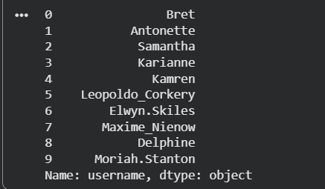

Q4 | You have two CSV files: 'orders.csv' (order_id, user_id, amount) and 'users.csv' (user_id, username). Load both into DataFrames using pathlib for file paths, then merge them on 'user_id' to show a combined table with username and amount.
Code | from pathlib import Path  DATA_DIR = Path("data")  DATA_DIR.mkdir(exist_ok=True)  orders_path = DATA_DIR / "orders.csv"  users_path = DATA_DIR / "users.csv"  pd.DataFrame({  "order_id": [101, 102, 103, 104, 105],  "user_id": [1, 2, 1, 3, 2],  "amount": [250.0, 899.5, 120.0, 430.0, 75.25],  }).to_csv(orders_path, index=False)  pd.DataFrame({  "user_id": [1, 2, 3],  "username": ["ananya", "rahul", "meera"],  }).to_csv(users_path, index=False)  orders_df = pd.read_csv(orders_path)  users_df_csv = pd.read_csv(users_path)  merged_df = orders_df.merge(users_df_csv, on="user_id", how="inner")  merged_df = merged_df[["order_id", "username", "amount"]]  merged_df
Output | 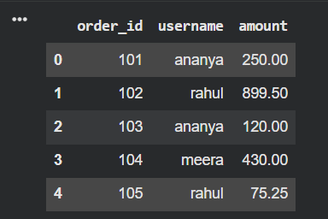

Q5 | Concatenate two DataFrames representing 'today_orders' and 'yesterday_orders' (each with columns: order_id, item, price), and display the combined DataFrame.<br><br><em><strong>Constraint:</strong> Use pd.concat() and reset the index after concatenation.</em>
Code | today_orders = pd.DataFrame({  "order_id": [201, 202, 203],  "item": ["Margherita Pizza", "Veg Biryani", "Cold Coffee"],  "price": [299.0, 220.0, 99.0],  })  yesterday_orders = pd.DataFrame({  "order_id": [198, 199, 200],  "item": ["Paneer Wrap", "Masala Dosa", "Chocolate Shake"],  "price": [149.0, 90.0, 130.0],  })  combined_orders = pd.concat([today_orders, yesterday_orders]).reset_index(drop=True)  combined_orders
Output | 